Process Flow for Processing Cash Advances and Liquidation:
1. Customer pays for the Processing Fees. An Acknowledgment Receipt (AR) is issued.
2. Staff initiates a Budget Request Processing (BRP) Form and receives the cash advance from Finance/Acctg.
A new “Budget Request Processing” request is created by staff. Use AR number as the reference.
a. Who creates this request? One person? Anyone?
They have assigned categories within the Processing-Roces staff:
LTOPF (New/Renewal) – Jo
FA Registration (New) – Ellen and Carla
FA Registration (Renewal) – Paul
Airgun Registration - Paul

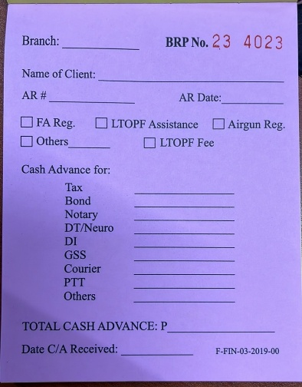

b. How much money is needed? Is the amount set? Will it change over time?
The amount changes depending on what is being paid (Notary, ID, PTT, etc) and for what type of application form (LTOPF New or LTOPF Renewal, FA Reg New or Renewal, Airgun, etc.)

3. Staff proceeds to secure/pay for the requirements, e.g. notary, ID, PTT, etc.. Some items are paid through Landbank online.
a. Need the complete list of payments and their amount.
Tax | Private - P4,000  Govt - P2,000  Senior Citizen - P3,200 | Landbank online
ID | For all - P200 | Landbank online; if re-print it’s cash over the counter in Landbank Crame
Notary | LTOPF (New/Renewal ) – P200  FA Reg (New) – P200  FA Reg (Renewal) – P100  Airgun – P200 | Cash
Drug Test/Neuro | LTOPF (New/Renewal) – P1,200  Neuro Only (re-take) – P900 | Cash - One Stop Shop Finance
Police Clearance | Normally paid by client but if special cases and paid by office - P157 | Online
GSS | P100 | Cash - One Stop Shop Finance
Courier | Case-to-case basis
PTT | P200 | Landbank online
Others | Ex: Representation to retrieve account – P1,000 | Cash – FEO
 | PTC, IT Matters, FEO Matters | Cash of up to P20,000 – FEO

b. Who will enter this update?
Staff who initiated the BRP Form will monitor and enter updates.

4. Staff submits a summary report to Finance/Acctg to liquidate the cash advance or the payment done through Landbank online, attaching proof of payment to the report.
a. What does this report look like?
There are 6 summary reports from Roces, grouped by type of expense. You will see the differences in the title of the report and the column headings.
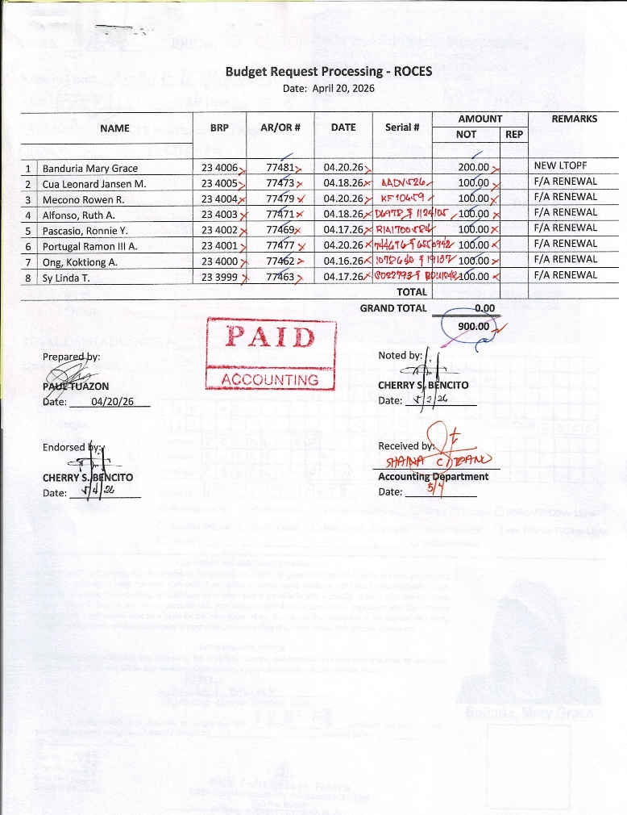

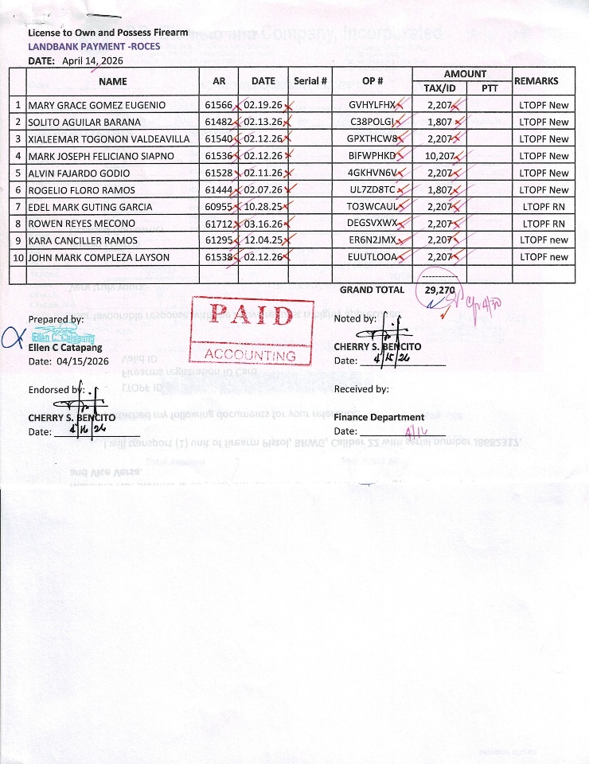

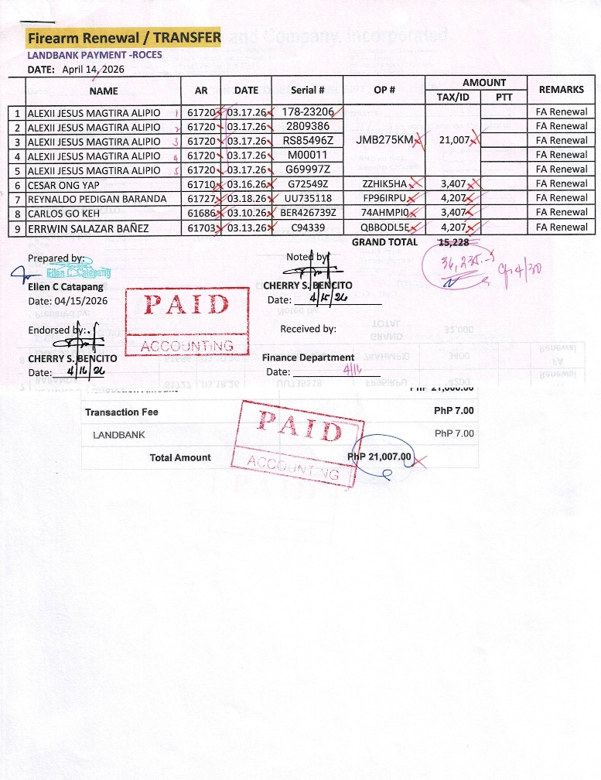

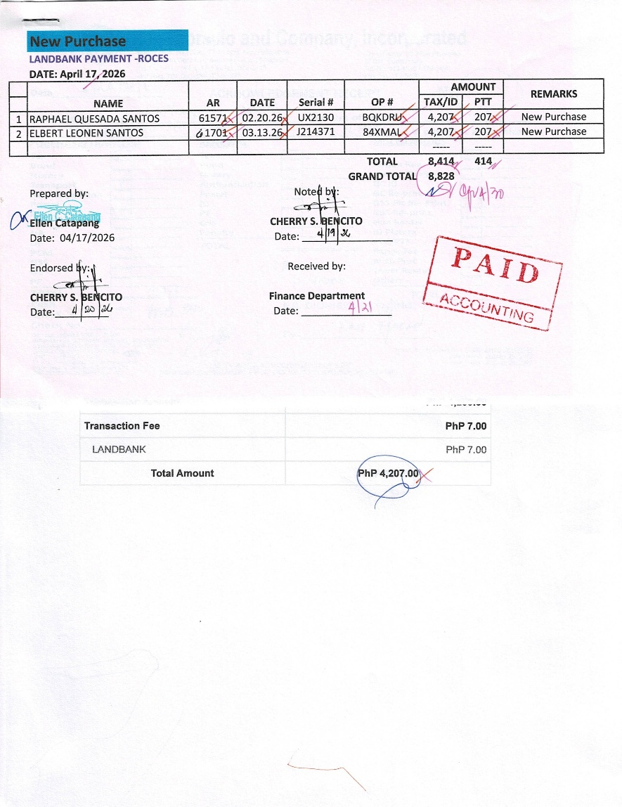

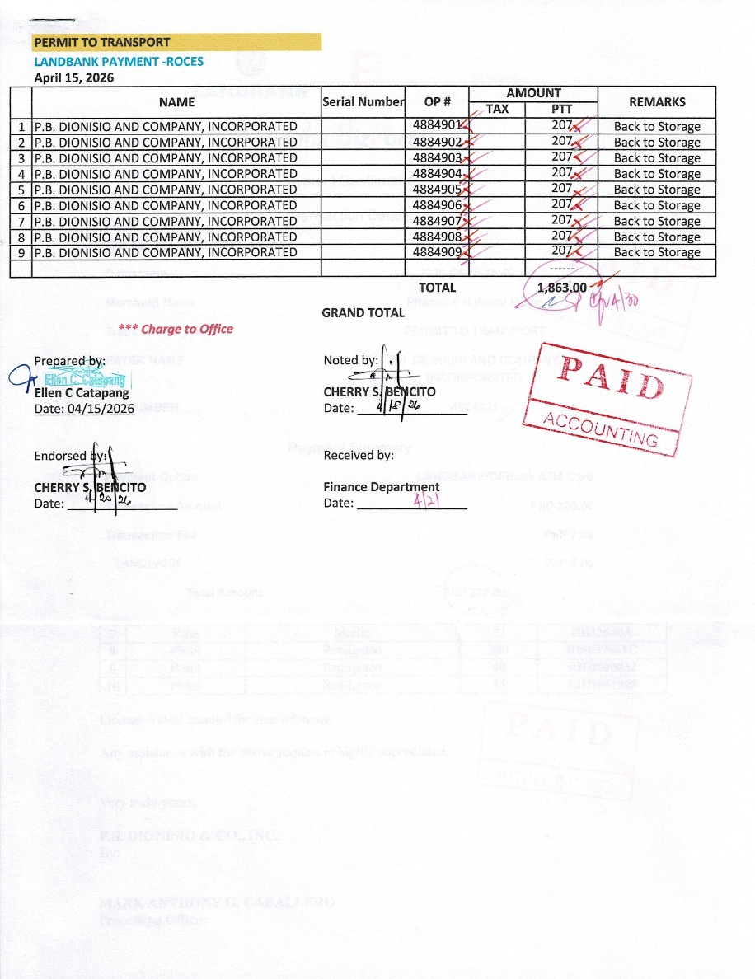

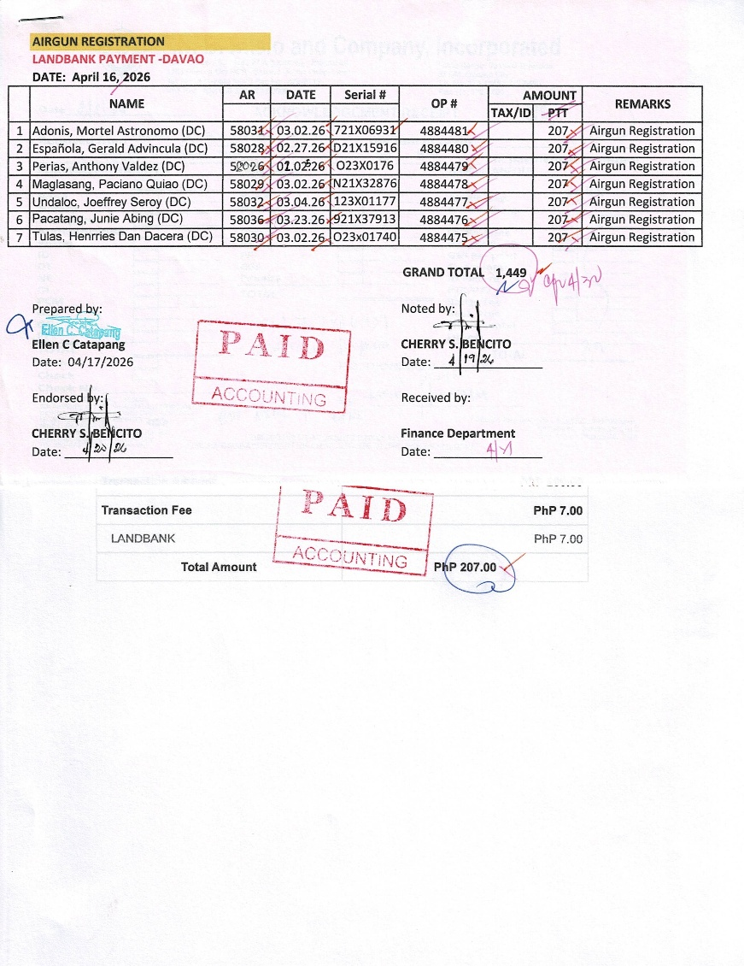

There is 1 summary report from Crame, which covers Representation, “Others”, “Piso Piso”:

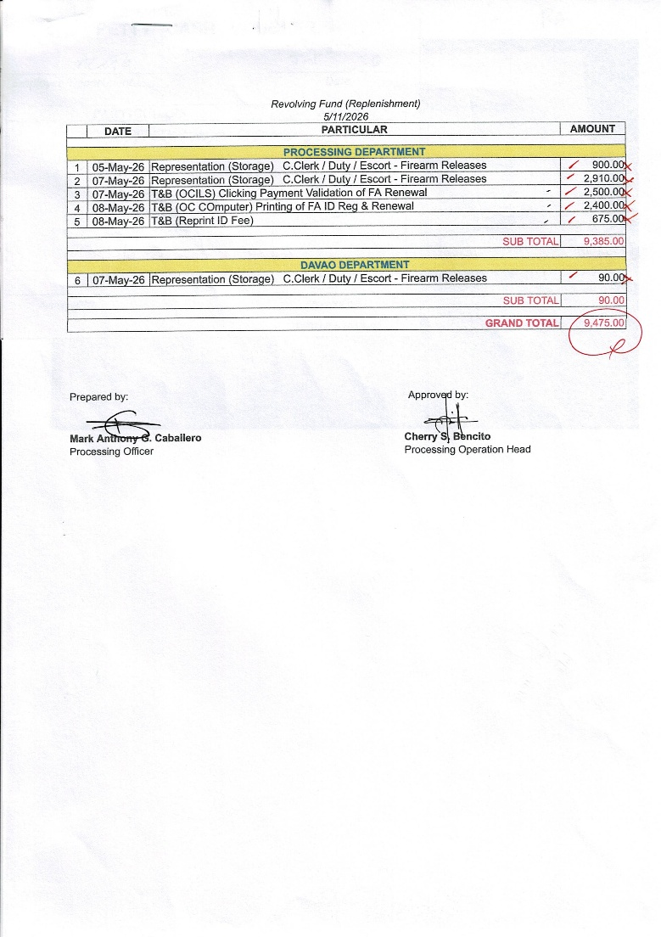
As an example, below is a list of names that we submit to FEO for ID Printing, “piso piso” is paid per name:

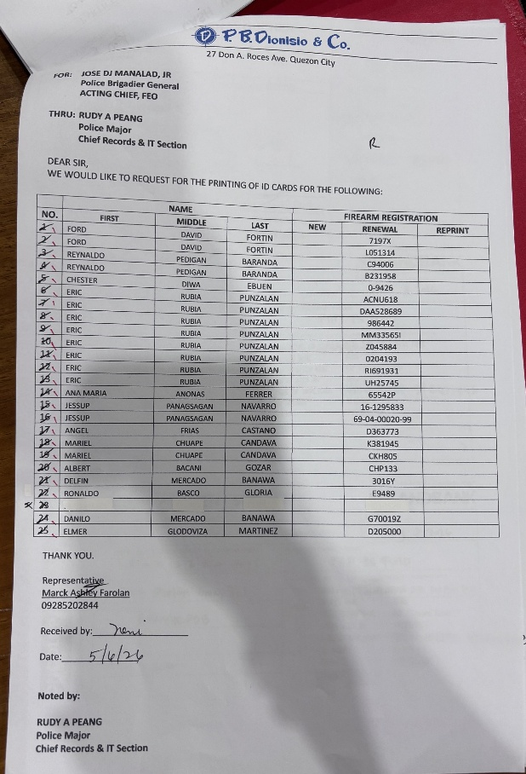

5. Finance/Acctg will validate accuracy of the report. At the moment it’s Cel who does this. Note her signature on the reports. I don’t know what system she uses to validate each expense. Rogel used to do this when he was still with Acctg. He would do it through an Excel file that he put together, with data extracted from Access.

6. Finance/Acctg issues disbursement voucher based on summary report.
a. This is outside the application. Will the request be marked completed? Who will do this?
Agree, the voucher issuance is outside the app.
Yes, the request should be marked as completed. One important feature needs to be that a request cannot be made twice. For example, staff requesting notary budget for Rica Popple under AR# 12345 can only be done once. To prevent double requests. And likewise, Finance/Acctg will have to be able to tag the specific item as “paid” so that they also don’t double-release funds for the same item.

7. After checking and approval, Finance/Acctg to prepare check that will replenish the cash in the fund.
a. Do we need to track the amount of cash in the fund?
The app does not need to do this.

